Do you have questions about your medications?

Bring them to the SoCAN Fall event:

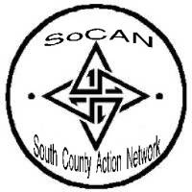

Meet the Pharmacist

Local pharmacists will be available to review your prescriptions,

over-the-counter medications, vitamins and supplements.



**Exhibitor Fair**

**Free Opportunity Drawings**

**Health Screenings**

**Flu shots**

**Health Presentations**

**Light Free Lunch**

**Tuesday, October 21, 2014**

**10:00am-2:00pm**

**Kimball Senior Center**

**1221 “D” Ave., National City, CA 91950**

**Spanish translation will be provided**

**(Map on Back)**

Please call:

(619) 336-6761

to reserve your spot for this event

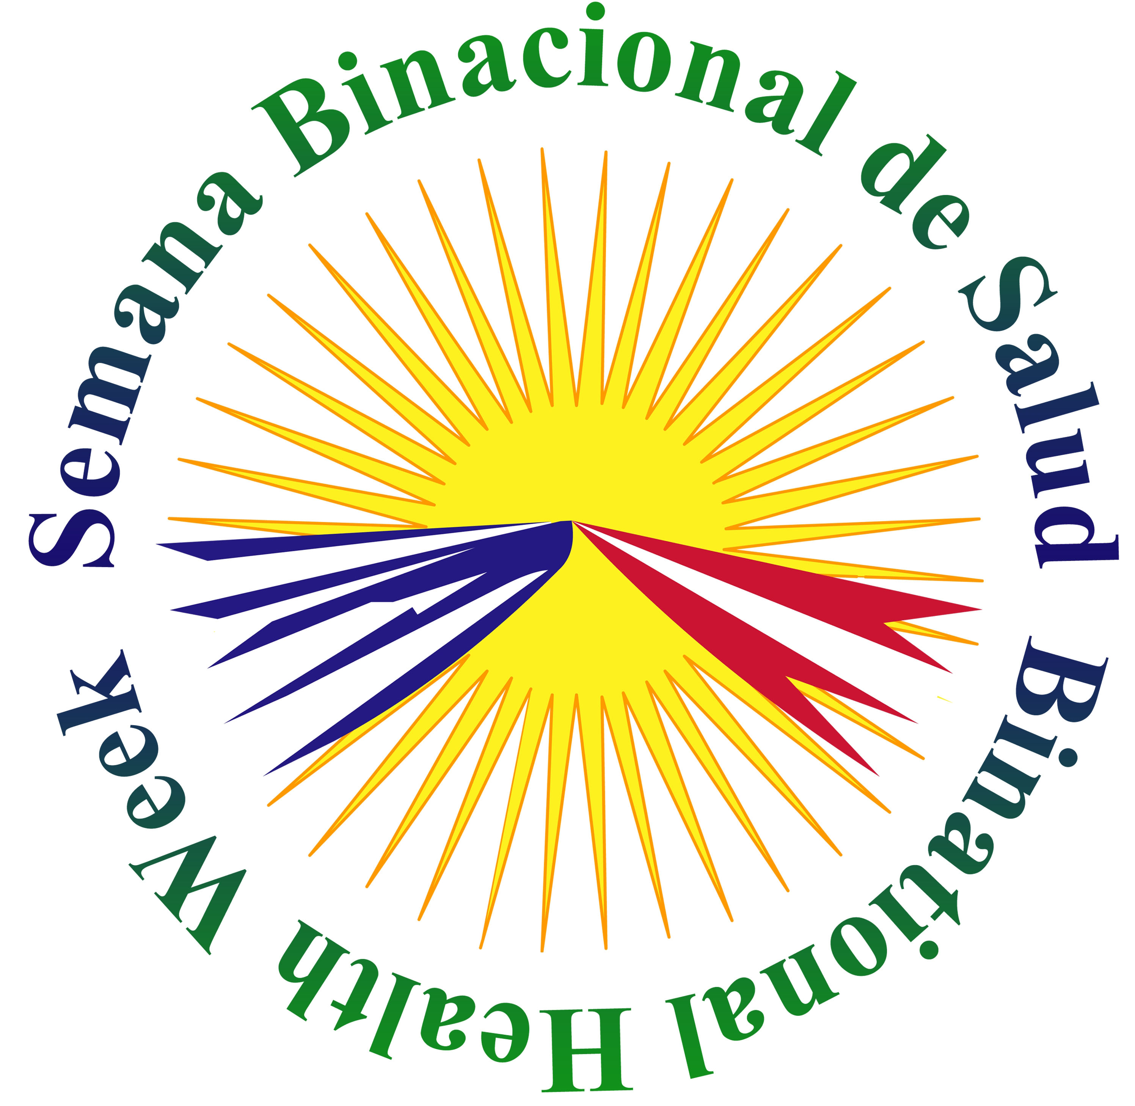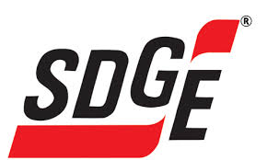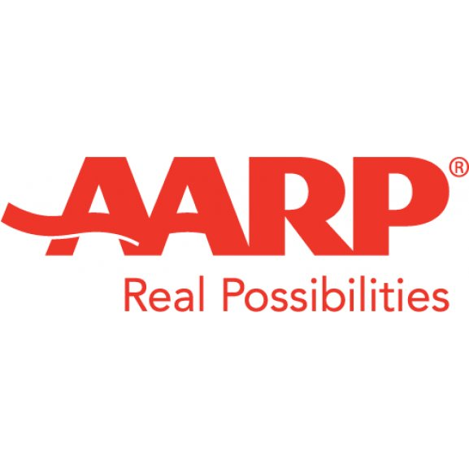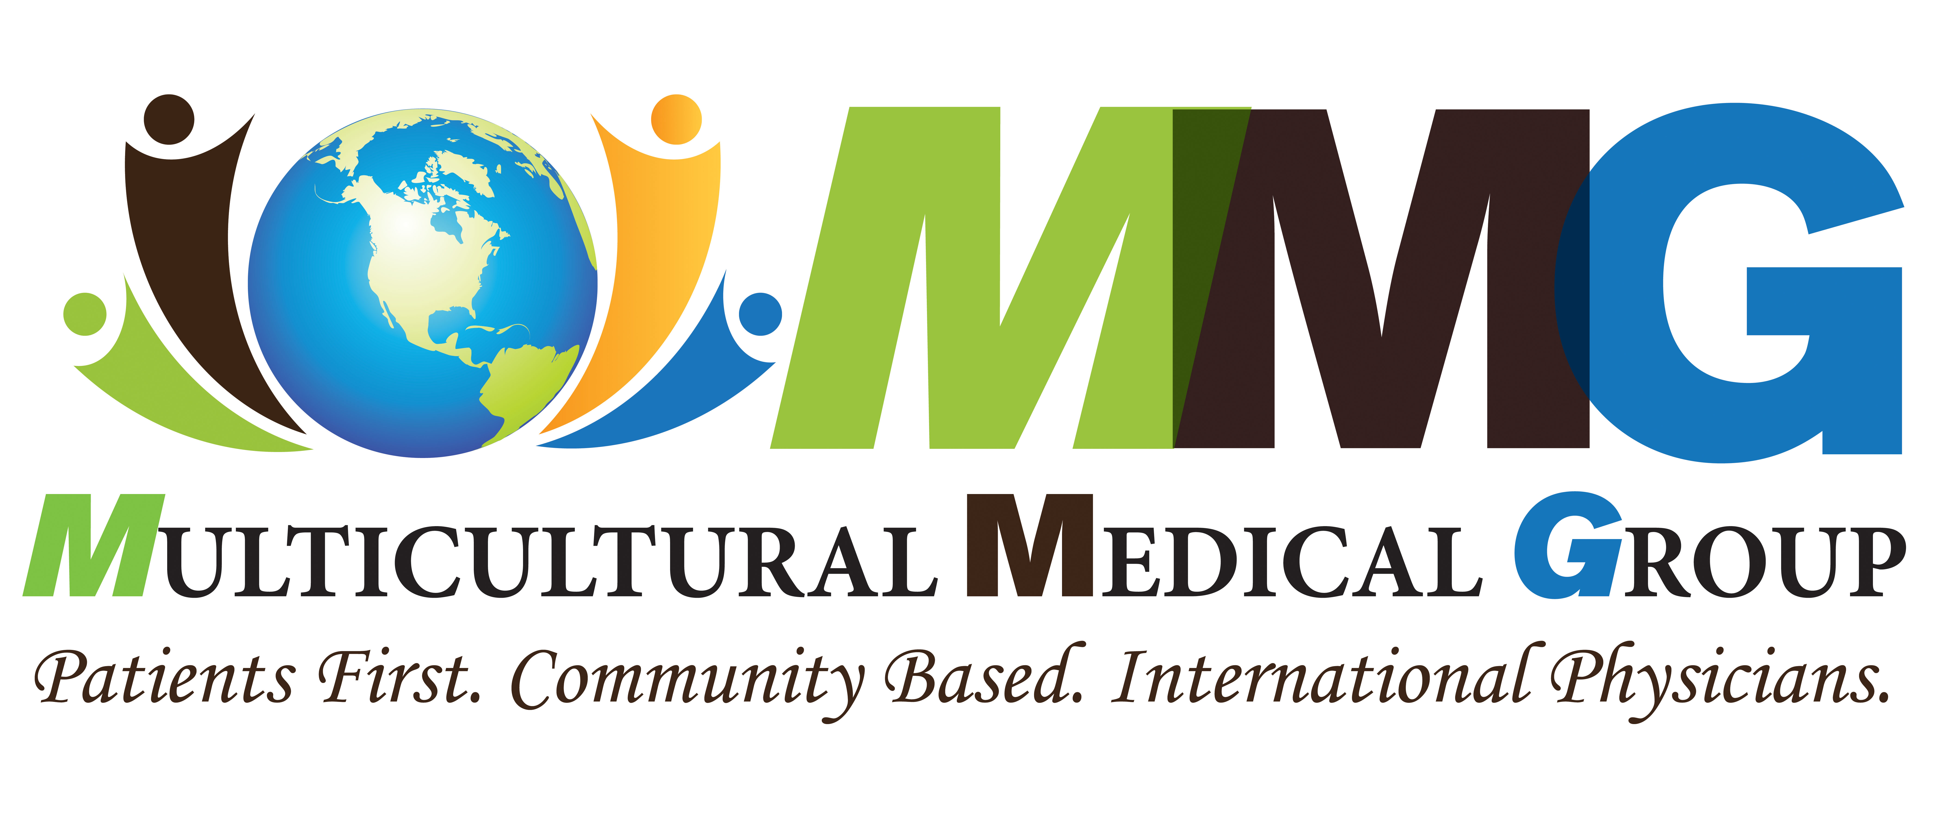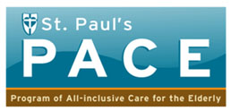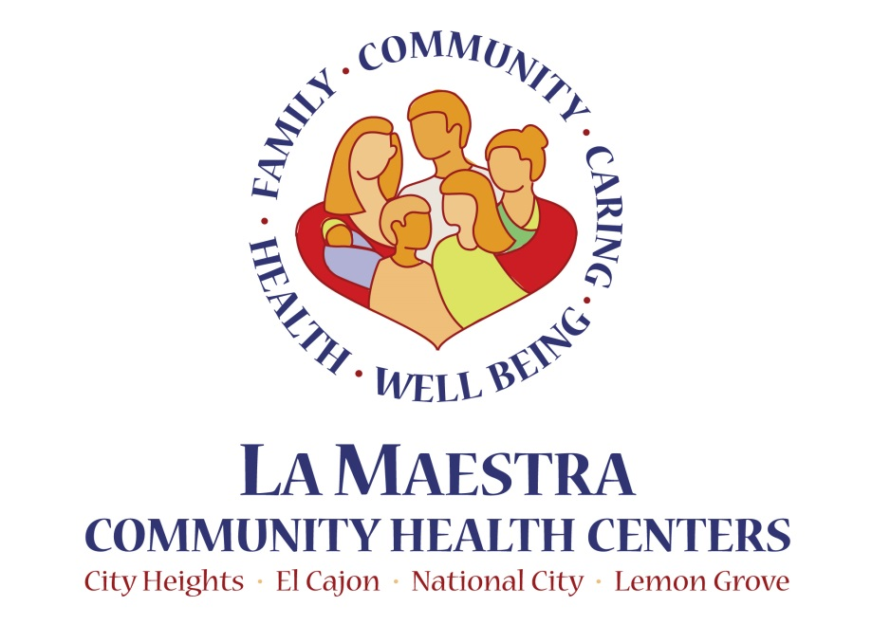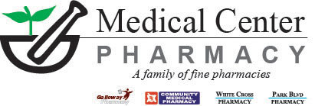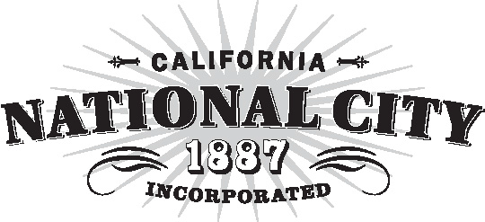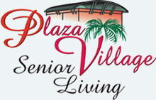

**Kimball Senior Center**

**1221 “D” Ave., National City, CA 91950**

